https://www.310cashforcars.com/
Index

- Improved Website Health
- Improved Website Speed
- Improved Website Usability
- Improved On-page SEO
- Improved Off-page SEO
- Added internal linking to key pages
- Built New Backlinks
- Built New Backlinks

- Keyword Ranking
Google search engine has started indexing your landing pages. Google keyword ranking is the position that your Landing Page is listed in Google when a user searches that phrase or keyword. A ranking of 1 means that you are at the top. If you are number 11, that means that you are on page 2 of Google as most search results have 10 listings per page. We worked hard and ranked your Landing Pages keywords on Google. Some keywords as an example are mentioned below;
 | Keywords | Search Engine | Current Ranking in Google SERP
1 | Cash for Classic Cars Sherman Oaks | Google.com | 1
2 | Vintage cars for cash Sherman Oaks | Google.com | 1
3 | Fast Cash for Cars Los Angeles | Google.com | 1
4 | Classic Cars for Cash Sherman Oaks | Google.com | 1
5 | Pickup Scrap Car service in Chatsworth | Google.com | 1
6 | Sell Antique Cars Sherman Oaks | Google.com | 1
7 | Cash for Cars Woodland Hills | Google.com | 1
8 | Cash for vintage car in Sherman Oaks | Google.com | 1
9 | Cash for Cars Fast Los Angeles | Google.com | 1
10 | Classic Car Buyers Sherman Oaks | Google.com | 1
11 | Sell Classic Car in Sherman Oaks CA | Google.com | 1
12 | Pickup Scrap auto service in Chatsworth | Google.com | 1
13 | Cash for Cars Services Woodland Hills | Google.com | 1
14 | Classic Car Pickup for Cash Sherman Oaks | Google.com | 1
15 | Sell My Vintage Car in Sherman Oaks | Google.com | 1
16 | Sell antique car for cash Sherman Oaks | Google.com | 1
17 | Pickup Scrap vehicle service in Chatsworth | Google.com | 1
18 | Money for Vintage Cars Sherman Oaks | Google.com | 1
19 | Cash for Vintage Cars Today Sherman Oaks CA | Google.com | 1
20 | Sell my car for cash Sylmar | Google.com | 1
21 | Pickup Scrap automobile service in Chatsworth | Google.com | 1
22 | Local classic cars buyers Sherman Oaks | Google.com | 1
23 | Pay Cash for Vehicles Woodland Hills | Google.com | 1
24 | Top dollar for classic cars Sherman Oaks | Google.com | 1
25 | Fast Vehicle for Cash Reseda CA | Google.com | 1
26 | Cash for old classic cars Sherman Oaks | Google.com | 1
27 | Cash for Classic auto Sherman Oaks | Google.com | 1
28 | Cash for Classic Vehicle Sherman Oaks | Google.com | 1
29 | Top Dollar for Vintage Cars Sherman Oaks | Google.com | 1
30 | Cash for Car Woodland Hills | Google.com | 1
31 | Best Cash for Cars in Sylmar | Google.com | 1
32 | Fast Cash for Cars in Sylmar | Google.com | 1
33 | Scrap Car Pick up in Chatsworth | Google.com | 1
34 | Cash for Vans in Canoga Park | Google.com | 1
35 | Lost title cars for sell Canoga Park | Google.com | 1
36 | Pickup Scrap Car in Chatsworth | Google.com | 1
37 | Money For Classic Cars Studio City | Google.com | 1
38 | Cash for Vehicles Woodland Hills | Google.com | 1
39 | Lost title cars for cash Canoga Park | Google.com | 1
40 | Cash for Car Fast Valley LA | Google.com | 1
41 | Sell Car for Cash Chatsworth Simi Valley | Google.com | 1
42 | Money for cars Studio City | Google.com | 1
43 | Cash for Cars in Valley LA | Google.com | 1
44 | Car for Cash in Chatsworth Simi Valley | Google.com | 1
45 | $500 Cash for Cars Santa Monica | Google.com | 1
46 | Cash for Car in Chatsworth Simi Valley | Google.com | 1
47 | Pay Cash for Cars in Sylmar | Google.com | 1
48 | Old Car Removal Chatsworth Simi Valley | Google.com | 1
49 | Fast Cash for Car Valley LA | Google.com | 1
50 | Car for cash in Valley LA | Google.com | 1
51 | Cash offer for classic cars Sherman Oaks | Google.com | 1
52 | Pay Cash for Trucks Woodland Hills | Google.com | 1
53 | Cash for Cars Service in West Los Angeles | Google.com | 1
54 | Pay Cash for Cars Woodland Hills | Google.com | 1
55 | Sell Cash for Cars in West Los Angeles | Google.com | 1
56 | Pay Cash for Vans Woodland Hills | Google.com | 1
57 | Get Cash for Vintage Cars in Sherman Oaks | Google.com | 1
58 | Emergency Cash for Cars in Sylmar | Google.com | 1
59 | Cash for old cars Sherman Oaks | Google.com | 1
60 | Sell my classic car fast in Sherman Oaks CA | Google.com | 1
61 | Sell My Classic Car Sherman Oaks | Google.com | 1
62 | Classic Car Removal for Cash Sherman Oaks | Google.com | 1
63 | Scrap My Car for Cash in Chatsworth Simi Valley | Google.com | 1
64 | Canoga Park fast car cash | Google.com | 1
65 | Classic Cars for Cash Studio City CA | Google.com | 1
66 | Top Dollar for Cars Chatsworth Simi Valley | Google.com | 1
67 | Lost Title Junk Car Studio City | Google.com | 1
68 | Cash for Cars $500 Santa Monica | Google.com | 1
69 | Money for Car in Chatsworth Simi Valley | Google.com | 1
70 | $500 cash for vehicle Santa Monica | Google.com | 1
71 | Cash for Vans in Woodland Hills | Google.com | 1
72 | Sell Scrap Car Chatsworth Simi Valley | Google.com | 1
73 | Old Car for Cash Chatsworth Simi Valley | Google.com | 1
74 | Title Lost Junk Car Studio City | Google.com | 1
75 | Cash for Sedans in Canoga Park | Google.com | 1
76 | Cash for vehicle $500 Santa Monica | Google.com | 1
77 | Cash for Old Car Chatsworth Simi Valley | Google.com | 1
78 | Instant Buy cars for cash in Canoga Park | Google.com | 1
79 | Lost Title Cars for Cash in Noho | Google.com | 1
80 | Old Car Pickup Chatsworth Simi Valley | Google.com | 1
81 | Car for Cash Chatsworth Simi Valley | Google.com | 1
82 | Salvage Car for Cash Marina Del Rey | Google.com | 1
83 | Cash for junk car Chatsworth Simi Valley | Google.com | 1
84 | Sell Your Car Chatsworth Simi Valley | Google.com | 1
85 | Sell Your truck near Chatsworth Simi Valley | Google.com | 1
86 | Cash For Trailers Woodland Hills | Google.com | 1
87 | Fast Cash for Your Car Valley/L.A | Google.com | 1
88 | Cash For Classic Car Studio City CA | Google.com | 1
89 | Cash for my car Chatsworth Simi Valley | Google.com | 1
90 | Classic car for cash in Woodland Hills | Google.com | 1
91 | Junk Vehicles Selling Noho | Google.com | 1
92 | Sell a Car for Cash in Van Nuys | Google.com | 1
93 | Cash For Vans near Noho | Google.com | 1
94 | Cash for trailers Woodland Hills | Google.com | 1
95 | Money for Classic Cars Woodland Hills | Google.com | 1
96 | Fast Cars for Cash Canoga Park | Google.com | 1
97 | Money for Classic Auto Woodland Hills | Google.com | 1
98 | Junk car removal Chatsworth Simi Valley | Google.com | 1
99 | Lost Title Junk Cars in North Hollywood | Google.com | 1
100 | Junk Car for Cash Chatsworth Simi Valley | Google.com | 1
101 | Rusted Car Buyers in Marina Del Rey | Google.com | 1
102 | Cash For Rusted Car Marina Del Rey | Google.com | 1
103 | Cash for Cars Sylmar LA | Google.com | 1
104 | Lost Title Cars for Cash North Hollywood | Google.com | 1
105 | Same day Cash for Cars Woodland Hills | Google.com | 1
106 | Payout For Your Car in Chatsworth Simi | Google.com | 1
107 | High Cash for Cars Sylmar CA | Google.com | 1
108 | Classic Vehicle for Cash Studio City CA | Google.com | 1
109 | Fair Cash for Car Chatsworth Simi Valley | Google.com | 1
110 | Sell Your Car in Chatsworth Simi Valley | Google.com | 1
111 | Buy Scrap Car for Cash Marina Del | Google.com | 1
112 | $500 Cash for Scrap Cars in Santa Monica | Google.com | 1
113 | Cash for Your Car Fast Valley LA | Google.com | 1
114 | Canoga Park classic cars for cash | Google.com | 1
115 | Buy Lost Title Car Studio City | Google.com | 1
116 | Sell sedan vehicle fast Canoga Park | Google.com | 1
117 | Sell vehicle fast Canoga Park | Google.com | 1
118 | Cash for Classic Cars Shaman Oaks | Google.com | 1
119 | Old classic cars fast in Sherman Oaks | Google.com | 1
120 | Sell Damaged Cars Marina Del Rey | Google.com | 1
121 | Buy Scrap Vehicles in Marina Del Rey | Google.com | 1
122 | Money for Junk Car Marina Del | Google.com | 1
123 | Buy junk vehicle in Marina Del Rey | Google.com | 1
124 | Buy Scrap Cars Marina Del Rey | Google.com | 1
125 | Cash For Fast Cars Reseda LA | Google.com | 1
126 | Scrap Vehicles Buyer Marina Del Rey | Google.com | 1
127 | Unwanted Vehicle for Cash Sylmar LA | Google.com | 1
128 | We buy cars for cash Canoga Park | Google.com | 1
129 | Purchase Scrap Cars in Marina Del Rey | Google.com | 1
130 | Car Take Away for Cash in Sylmar | Google.com | 1
131 | Money for Junk Cars Marina Del Rey | Google.com | 1
132 | Damaged Car for Cash Marina Del Rey | Google.com | 1
133 | Best Classic Car Buyers in Sherman Oaks | Google.com | 1
134 | Classic Cash for Car Pasadena CA | Google.com | 1
135 | Buy Scrap Cars in Marina Del Rey | Google.com | 1
136 | Get Money for Cars in Sylmar | Google.com | 1
137 | Junk Car Removal in Chatsworth Simi Valley | Google.com | 1
138 | Cash For Fast Cars San Fernando Valley | Google.com | 1
139 | Cash for Junk Cars Marina Del Rey | Google.com | 1
140 | Cash for SUVs in Canoga Park | Google.com | 1
141 | Scrap Car buyers Marina Del Rey | Google.com | 1
142 | Old car removal San Fernando Valley | Google.com | 1
143 | Clunkers car removal San Fernando Valley | Google.com | 1
144 | Cash For Truck in Woodland Hills | Google.com | 1
145 | Old Car Removal Company San Fernando Valley | Google.com | 1
146 | Sell my classic car for cash Sherman Oaks | Google.com | 1
147 | Buyers Classic Car Sherman Oaks | Google.com | 1
148 | Sell Damaged Cars Marina Del Rey | Google.com | 1
149 | Buy Scrap Vehicles in Marina Del Rey | Google.com | 1
150 | Purchase Unwanted Cars in Sylmar | Google.com | 1
151 | Instant Cash for Classic Cars Sherman Oaks | Google.com | 1
152 | Sell Antique Car Sylmar | Google.com | 1
153 | Fast Cash for Your Cars Sylmar | Google.com | 1
154 | Cash For Old Car Sylmar | Google.com | 1
155 | Money For Cars near Sylmar | Google.com | 1
156 | Get Car for Cash in Sylmar | Google.com | 1
157 | Cash for Automobile in Sylmar | Google.com | 1
158 | Money For Old Car Sylmar | Google.com | 1
159 | Classic Automobile for Cash Sylmar | Google.com | 1
160 | Money For SUV In Sylmar | Google.com | 1
161 | Unwanted Car for Cash in Sylmar LA | Google.com | 1
162 | Money For Car Sylmar | Google.com | 1
163 | Cash For Car Service Sylmar | Google.com | 1
164 | Fast Cash for Car Sylmar LA | Google.com | 1
165 | Cash for scrap car Studio City | Google.com | 1
166 | Cash For SUV in Sylmar | Google.com | 1
167 | Buy Cars for Cash Near Sylmar | Google.com | 1
168 | Used Vehicle for Cash Sylmar | Google.com | 1
169 | Get Cash for Vehicles in Sylmar | Google.com | 1
170 | Get Cash for Cars Sylmar | Google.com | 1
171 | Sell a Car for Cash in Northridge | Google.com | 1
172 | Remove Old Car in Chatsworth | Google.com | 1
173 | Fast Junk Car Buyer Marina Del Rey | Google.com | 1
174 | Sell Old Automobile Sylmar | Google.com | 1
175 | Cash for Scrap Cars in Chatsworth | Google.com | 1
176 | We Buy Auto for Cash in Canoga Park CA | Google.com | 1
177 | Fast Car Cash in Reseda | Google.com | 1
178 | We Buy Automobiles for Cash in Canoga Park | Google.com | 1
179 | Junk Vehicles Selling in Sylmar LA | Google.com | 1
180 | Get Cash for Vehicle Sylmar LA | Google.com | 1
181 | Unwanted Vehicles for Cash Sylmar | Google.com | 1
182 | Sell Used Car in Sylmar | Google.com | 1
183 | Buy Unwanted Vehicle Sylmar LA | Google.com | 1
184 | Quick Cash for Car Sylmar | Google.com | 1
185 | Sell My Scrap Car Sylmar | Google.com | 1
186 | Junk Car Worth in Sylmar | Google.com | 1
187 | Online Classic Car Buyers Sherman Oaks | Google.com | 1
188 | Sell Unwanted Car Sylmar | Google.com | 1
189 | Money for Vehicles Woodland Hills | Google.com | 1
190 | Old scrap car purchaser Sylmar | Google.com | 1
191 | Sell Unwanted Vehicle Sylmar | Google.com | 1
192 | Sell my scrap vehicle Sylmar | Google.com | 1
193 | Sell my junk cars in Sylmar LA | Google.com | 1
194 | Cars for cash West Los Angeles | Google.com | 1
195 | Junk Cars for cash West Los Angeles | Google.com | 1
196 | Junk Cars Buyers in Sylmar | Google.com | 1
197 | Reliable Junk Car Buyers in Marina Del Rey | Google.com | 1
198 | Pickup Vehicles for Cash Sylmar CA | Google.com | 1
199 | Cash for Cars Studio City | Google.com | 1
200 | Money for Scrap Cars Marina Del Rey | Google.com | 1
201 | Cash for SUVs Woodland Hills | Google.com | 1
202 | Money for junk car Sylmar | Google.com | 1
203 | Cash for Unwanted Car Sylmar | Google.com | 1
204 | Sell Scrap Vehicle in Sylmar LA | Google.com | 1
205 | Cash for Junk Car Sylmar | Google.com | 1
206 | Junk Car for Cash Sylmar | Google.com | 1
207 | Pickup cars for Cash in Sylmar | Google.com | 1
208 | Money for Cars West Los Angeles | Google.com | 1
209 | Buy Junk Cars in Marina Del Rey | Google.com | 1
210 | Fast Cash for Cars Reseda | Google.com | 1
211 | Cash For Vans North Hollywood | Google.com | 1
212 | Get Cash for Car in Sylmar | Google.com | 1
213 | Cash For Damaged Cars in Sylmar | Google.com | 1
214 | Money for junk cars in Sylmar | Google.com | 1
215 | Quick Car for Cash in Reseda | Google.com | 1
216 | Cash for Junk Vehicle in Sylmar | Google.com | 1
217 | Cash For Vehicles in Sylmar | Google.com | 1
218 | Automobiles For Cash Sylmar | Google.com | 1
219 | Fast Car Cash service in Reseda | Google.com | 1
220 | Damaged Car for Cash Marina Del Rey | Google.com | 1
221 | Fast Cash for Cars in Woodland Hills | Google.com | 1
222 | Fast Classic Car Buyers in Sherman Oaks | Google.com | 1
223 | Scrap Car for Cash Chatsworth Simi Valley | Google.com | 1
224 | No title cash for vehicle Santa Monica | Google.com | 1
225 | Cash for Classic Cars Studio City | Google.com | 1
226 | Cash for Cars in West Los Angeles | Google.com | 1
227 | Cash for Cars in Pasadena/Glendale | Google.com | 1
228 | Sell Salvage Car Sylmar | Google.com | 1
229 | Top dollar classic car buyers Sherman Oaks | Google.com | 1
230 | Pickup Scrap vehicle in Chatsworth | Google.com | 1
231 | Sell Junk Auto in Sylmar CA | Google.com | 2
232 | Sell Junk Car in Sylmar CA | Google.com | 2
233 | Cash for Cars Service Sylmar | Google.com | 2
234 | Best Cash for Cars Woodland Hills | Google.com | 2
235 | Fast Cash Cars Los Angeles | Google.com | 2
236 | Junk Car Removal in Santa Monica | Google.com | 2
237 | Scrap Car Pickup Service in Santa Monica | Google.com | 2

- ON-Page Status
ON-PAGE SEO is very important for the betterment of a website. FTS has taken professional steps to enhance the working, and ranking of this Website in all categorical Search Engines like Google, Bing, Yahoo, etc.
Activity | Status
Improve Website Speed | 95%
SEO Meta Tags | 85%
Optimized URL | 95%
Google Search Console | Verify
Title Optimized | 100%
H1, H2, H3 TAGS | 100%
Meta Description | 100%
Loading Speed | 92+
Image Alt Tags | 80%
Schema Markup | Enable
Robot.txt | Enable
XML Sitemap | Submit
Index Optimization | 80%
- Website URLs
This Section Represents the website’s all-page links. The FTS team worked hard to set the Optimized website slug. Every page has a unique slug and these slugs play a keen role in website ranking. The “310 Cash for Cars” complete website URLs are given below:
- https://www.310cashforcars.com/
- https://www.310cashforcars.com/blog/
- https://www.310cashforcars.com/shop/
- https://www.310cashforcars.com/sylmar/
- https://www.310cashforcars.com/reseda/
- https://www.310cashforcars.com/burbank/
- https://www.310cashforcars.com/van-nuys/
- https://www.310cashforcars.com/services/
- https://www.310cashforcars.com/chatsworth/
- https://www.310cashforcars.com/canoga-park/
- https://www.310cashforcars.com/los-angeles/
- https://www.310cashforcars.com/santa-monica/
- https://www.310cashforcars.com/contact-form/
- https://www.310cashforcars.com/classic-cars/
- https://www.310cashforcars.com/junk-vehicles/
- https://www.310cashforcars.com/santa-clarita/
- https://www.310cashforcars.com/marina-del-rey/
- https://www.310cashforcars.com/woodland-hills/
- https://www.310cashforcars.com/lost-title-help/
- https://www.310cashforcars.com/west-los-angeles/
- https://www.310cashforcars.com/glendale-pasadena/
- https://www.310cashforcars.com/cash-for-cars-northridge/
- https://www.310cashforcars.com/cash-for-cars-santa-monica/
- https://www.310cashforcars.com/junk-car-buyers-canoga-park/
- https://www.310cashforcars.com/junkyard-north-hollywood-ca/
- https://www.310cashforcars.com/old-car-removal-santa-monica/
- https://www.310cashforcars.com/cash-for-cars-in-los-angeles/
- https://www.310cashforcars.com/lost-title-cars-studio-city-ca/
- https://www.310cashforcars.com/cars-buyers-north-hollywood-ca/
- https://www.310cashforcars.com/old-car-removal-near-chatsworth/
- https://www.310cashforcars.com/old-classic-cars-north-hollywood/
- https://www.310cashforcars.com/we-buy-crash-cars-sherman-oaks-ca/
- https://www.310cashforcars.com/san-fernando-valley-cash-for-cars/
- https://www.310cashforcars.com/cash-for-classic-cars-sherman-oaks/
- https://www.310cashforcars.com/junk-car-pick-up-service-northridge/
- https://www.310cashforcars.com/fast-classic-car-buyers-sherman-oaks/
- https://www.310cashforcars.com/junk-car-pickup-service-santa-monica/
- https://www.310cashforcars.com/car-recycling-service-north-hollywood/
- https://www.310cashforcars.com/local-junk-car-removal-north-hollywood/
- https://www.310cashforcars.com/old-car-removal-near-san-fernando-valley/
- https://www.310cashforcars.com/sell-my-classic-car-for-cash-sherman-oaks/
- https://www.310cashforcars.com/local-junk-car-removal-san-fernando-valley/
- https://www.310cashforcars.com/san-fernando-valley-cash-for-cars/van-nuys/
- https://www.310cashforcars.com/cash-for-classics-marina-del-ray-310-cash-for-cars/
4. OFF-PAGE STATUS
This section specifies the OFF-Page SEO status of the Website. OFF Page SEO plays the main role to rank the website in Search Engines. The team has endorsed the website on social media platforms likewise they have done social bookmarking, article submission, and blogs related to your niche.
Activity | Status
Social Bookmarking | 10308
Social Media Sharing | 10314
Internal Links | 228
Backlinks | 10327
Social Media Platforms | Pinterest, WordPress, Blogger
5. Optimized Website Speed
Google started using site speed as a ranking signal in their algorithm way back in 2020, and it continues to serve as one of the many factors that determine where your website shows up in the search results.
Site speed reflects how quickly a website responds to web requests.
Speeding up websites is important not just to site owners, but to all Internet users. Faster sites create happy users and we’ve seen in our internal experience that when a site responds slowly, visitors spend less time there.
Google knows that sending people to slow-loading websites can wreak havoc on the user experience, so it comes as no surprise that the search giant still places value on site speed.
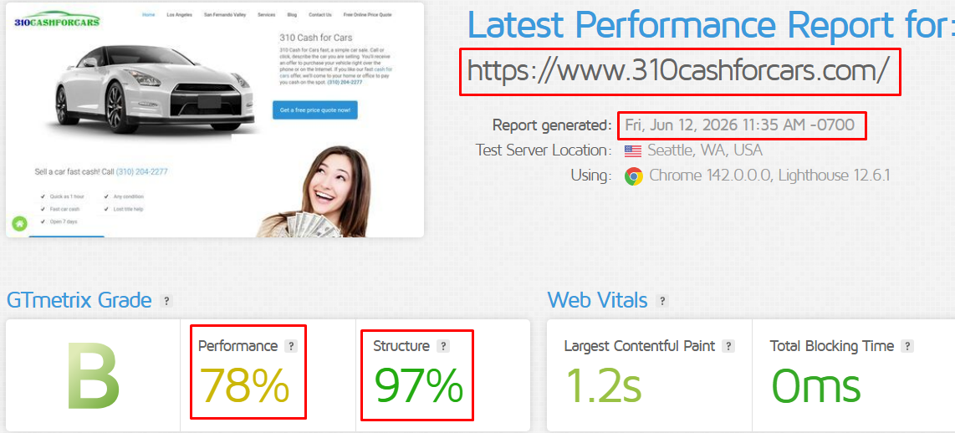
6. Optimized Website SEO
Google’s official tool Lighthouse runs various tests to establish how well a website or app can be crawled by search engines and displayed in the search results.
Lighthouse currently runs 13 audits within the search engine optimization category. These mainly look at mobile-friendliness or PWA, the correct application of structured data and tags like canonicals, hreflang, titles, and meta descriptions, and whether a page can be crawled by search engine bots.
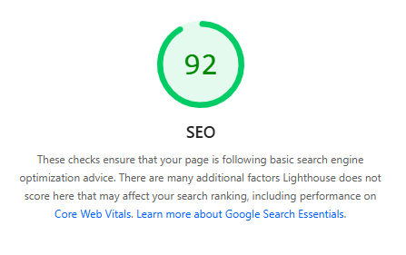
7. Website Sitemap Generated
A sitemap tells Google which pages and files you think are important to your site and also provides valuable information about these files: For example, pages, when the page was last updated, how often the page is changed, and any alternate language versions of a page.
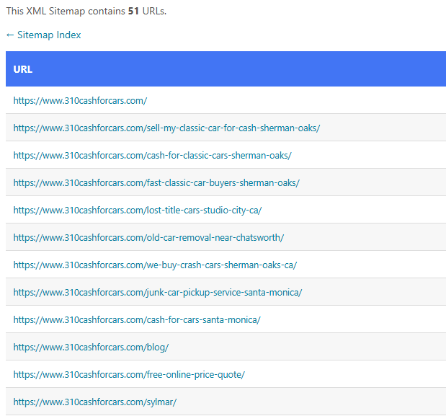
8. SCREENSHOTS
Ranked Keyword => Cash for Classic Cars Sherman Oaks
Click Here to See the results.
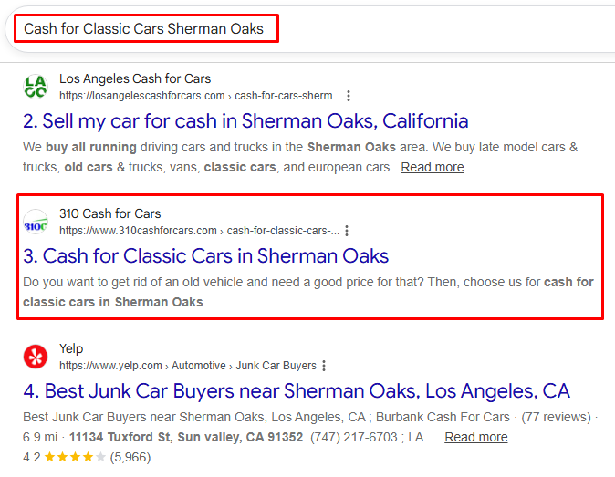
Ranked Keyword => Lost title cars for cash Canoga Park
Click Here to See the results.
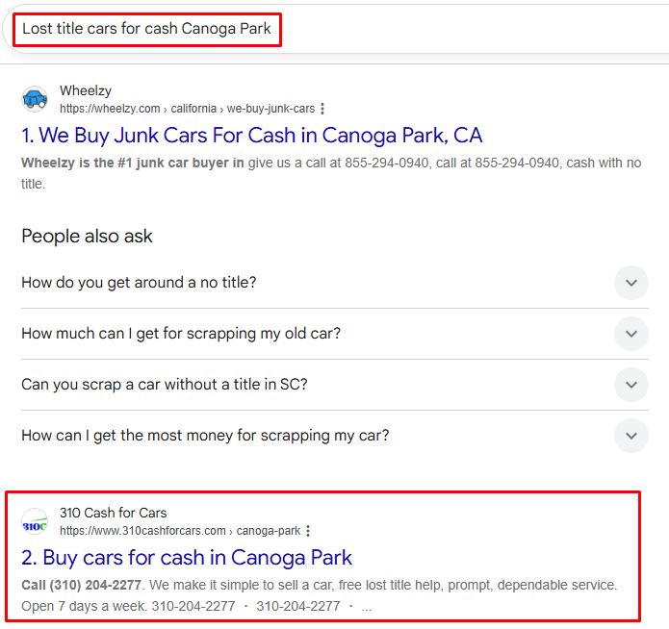
Ranked Keyword => Fast Cash for Cars Los Angeles
Click Here to See the results.
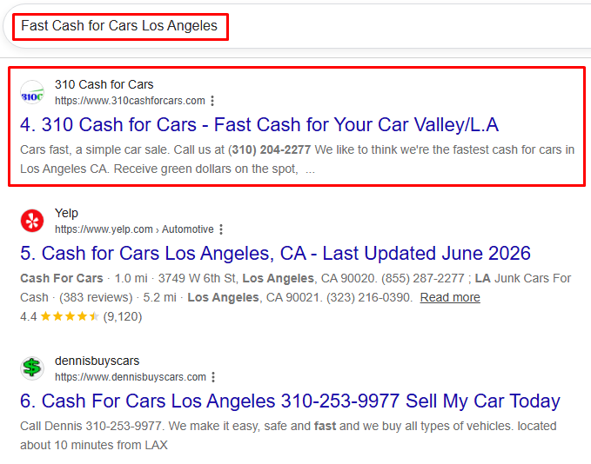
Ranked Keyword => Cash for Cars Woodland Hills
Click Here to See the results.
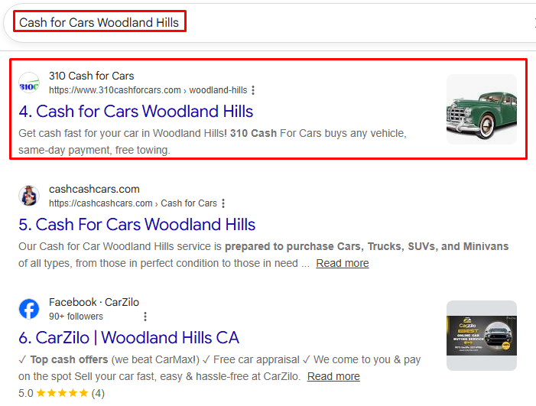

Ranked Keyword => Pay Cash for Vehicles Woodland Hills
Click Here to See the results.
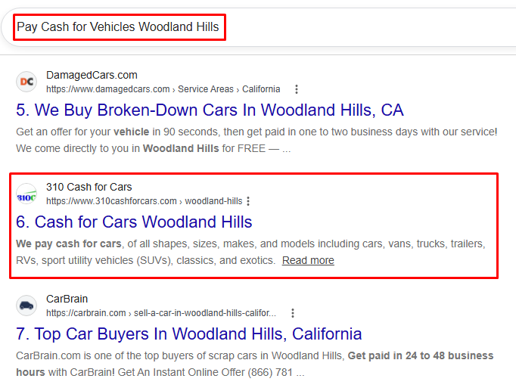
9. Backlinks URL’s
The team has properly made backlinks. The work is done according to White Hat SEO. Google favors this backlink technique thus making it highly effective. The sample links are given below.
https://flip.it/AW8fWH
https://flip.it/D0AuKN
https://flip.it/SKv9Pz
https://flip.it/zZ45VL
https://flip.it/JUJ8Ce
https://flip.it/tI5v.g
https://www.pearltrees.com/michealjordan02/usa-local-services/id101486338#item799681746
https://www.pearltrees.com/michealjordan02/usa-local-services/id101486338#item799681805
https://www.pearltrees.com/michealjordan02/usa-local-services/id101486338#item799681865
https://www.pearltrees.com/michealjordan02/usa-local-services/id101486338#item799681924
https://www.pearltrees.com/michealjordan02/usa-local-services/id101486338#item799681957
https://www.pearltrees.com/michealjordan02/usa-local-services/id101486338#item799682022
https://usalocalservices5216.blogspot.com/2026/06/choosing-right-junk-car-buyers-in.html
https://usalocalservices5216.blogspot.com/2026/06/old-car-removal-in-chatsworth-for.html
https://usalocalservices5216.blogspot.com/2026/06/understanding-value-when-you-sell-my.html
https://usalocalservices5216.blogspot.com/2026/06/junk-car-pick-up-service-in-northridge.html
https://usalocalservices5216.blogspot.com/2026/06/old-car-removal-in-san-fernando-valley.html
https://usalocalservices5216.blogspot.com/2026/06/junk-car-removal-in-san-fernando-valley.html
https://albertjohnblog433.wordpress.com/2026/06/02/how-old-car-removal-in-chatsworth-supports-vehicle-recycling/
https://albertjohnblog433.wordpress.com/2026/06/02/junk-car-buyers-in-canoga-park-required-documents-and-process/
https://albertjohnblog433.wordpress.com/2026/06/02/eco-friendly-benefits-of-junk-car-pick-up-service-in-northridge/
https://albertjohnblog433.wordpress.com/2026/06/02/how-to-get-the-best-value-from-old-car-removal-in-san-fernando-valley/
https://albertjohnblog433.wordpress.com/2026/06/02/benefits-of-junk-car-removal-in-san-fernando-valley-for-vehicle-owners/
https://albertjohnblog433.wordpress.com/2026/06/02/sell-my-classic-car-for-cash-in-sherman-oaks-everything-you-need-to-know/
https://albertjohn2243.wixsite.com/my-site-1/post/what-to-expect-from-old-car-removal-in-chatsworth-services
https://albertjohn2243.wixsite.com/my-site-1/post/how-to-get-the-best-deal-from-junk-car-buyers-in-canoga-park
https://albertjohn2243.wixsite.com/my-site-1/post/what-to-expect-from-old-car-removal-services-in-san-fernando-valley
https://albertjohn2243.wixsite.com/my-site-1/post/benefits-of-junk-car-pick-up-service-in-northridge-for-vehicle-owners
https://albertjohn2243.wixsite.com/my-site-1/post/how-junk-car-removal-in-san-fernando-valley-supports-vehicle-recycling
https://albertjohn2243.wixsite.com/my-site-1/post/eco-friendly-benefits-when-you-sell-my-classic-car-for-cash-in-sherman-oaks

OUR TARGETS
FTS is highly dedicated to providing result-oriented work. Our sole priority is you! We put all of our efforts into enhancing your business facility to the fullest level. Next month our main focus will be on:
- Increase Organic traffic by 95% by the end of the year.
- In this month FTS highly focuses on ranking your site on Google’s first page.
- The FTS team will generate new leads per month through SEO.
- We will work on new content to index more keywords in Google.
- The FTS team highly focuses on improving existing keyword positions in different Search Engines.
- Increase website DA to rank on Google’s first page for a lifetime.

Thanks!
Regards:
Firm Tech LLC

